Jay A Career
  - Assignment 2 • Game Design Document
Free realism upgrade / revised implementation
Amr Hazem El Kotit
GUC ID: 58-14399
DMET909 • Video Game Design
Revision: 13 October 2026
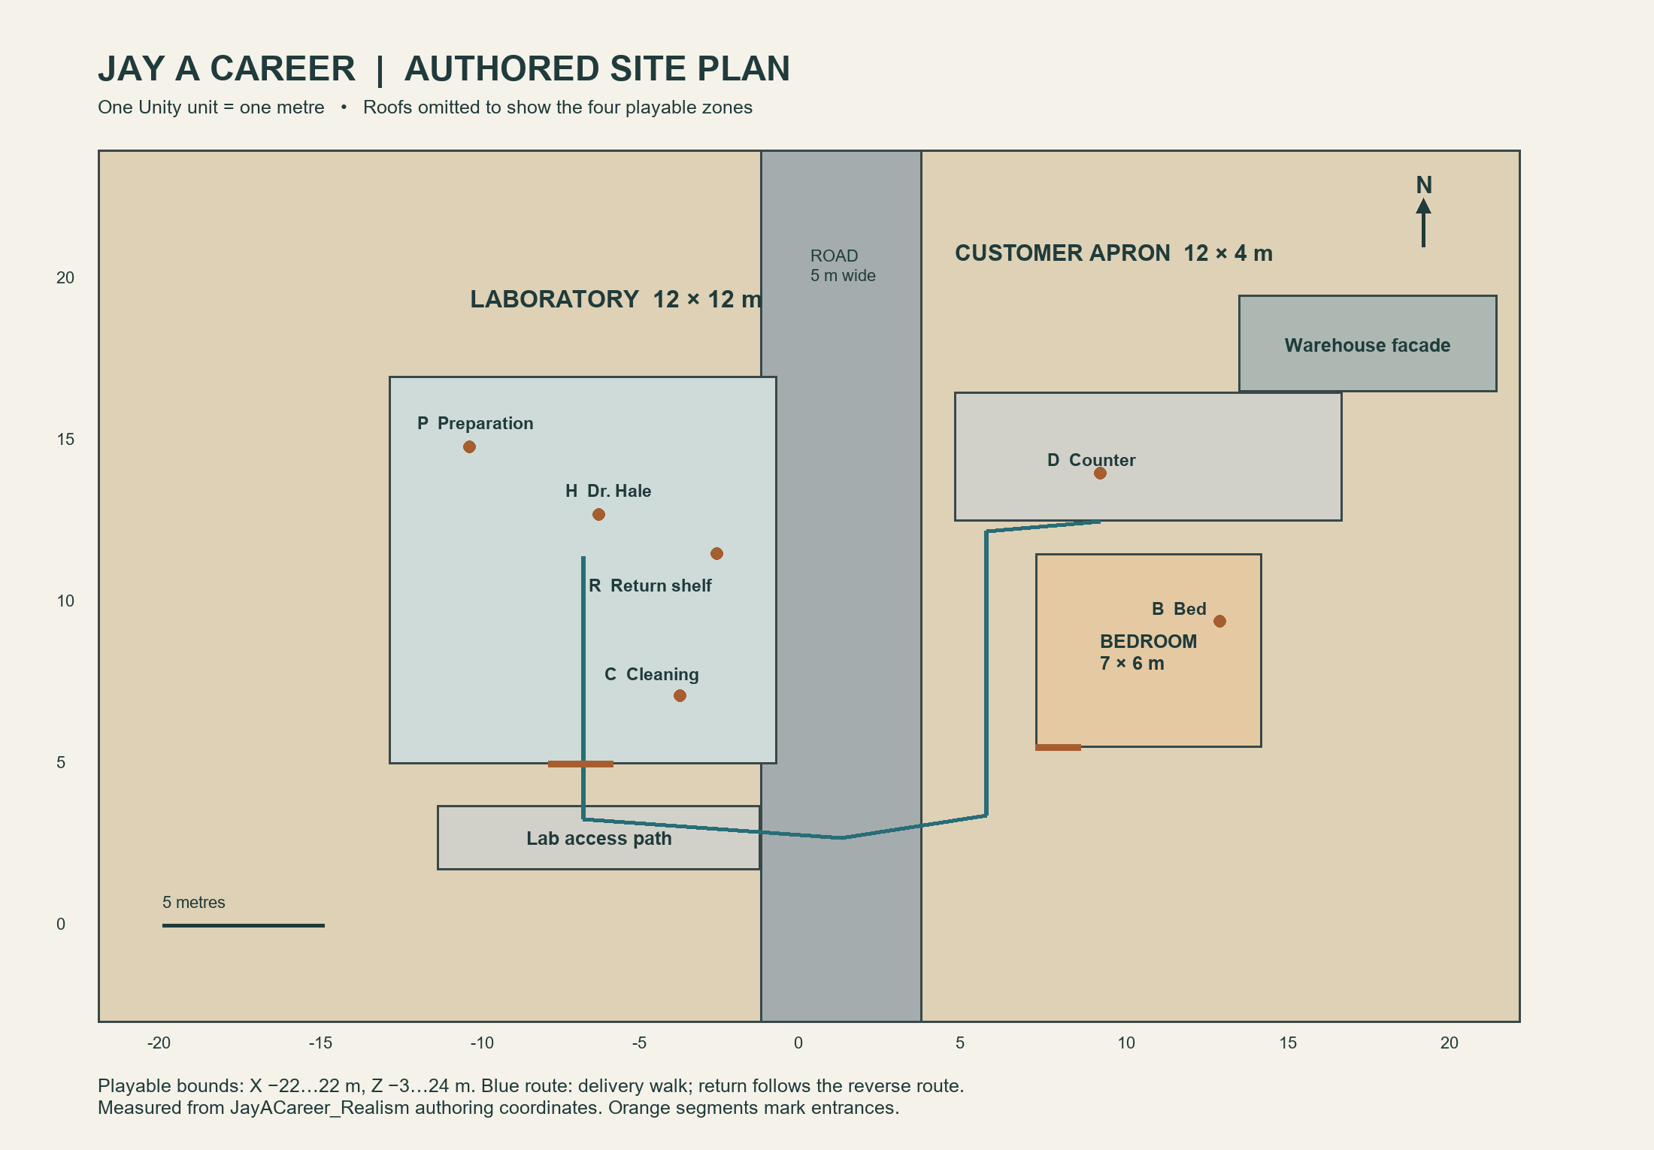
The compact site connects preparation, delivery and rest without a larger town.

Experience
A grounded, fictional desert laboratory and delivery game. Jay receives a briefing, handles one sealed package, negotiates with a customer, cleans the workspace and begins another day. The package is abstract: the game contains no real production procedure.

Submission scope
This revision documents the authored JayACareer_Realism scene. Earlier Assignment 1 work and the previous Assignment 2 document remain preserved. The game, map, screenshots, evidence reports and this document should be reviewed together.

Design overview

Player role and motivation
Jay is a junior worker in a small industrial site. The daily objective creates a readable order of tasks while negotiation introduces a modest financial choice. The player earns cash within the current session and learns the relationship between delivery, cleanup and rest by completing repeatable days.

Design pillars
Believable scale: human proportions, enclosed rooms and manufactured furniture establish a consistent metre-based world. Readable work: preparation, storage and cleaning have separate locations. Reliable consequences: one package and one settlement belong to each day. Compact traversal: walking connects every task without driving or a large city.

Art direction
The laboratory uses cool fixtures, painted cabinets, glass vessels and steel furniture. Exterior sand, worn asphalt, gravel and utility equipment support the desert setting. Warm bedroom light marks rest. Surface wear is restrained so interactions remain distinguishable from decoration.

Requirements source
Assignment 2 (Assignment ).pdf, pages 1–3, is the requirements source. It asks for locations, at least 30 distinct objects, scale, boundaries, time, at least 20 mechanics, five action demonstrations, three Cinemachine behaviours and three lighting behaviours. Its stated submission time is October 18 at 4 PM, with no extensions; the PDF does not state a year.

Reading guide
Pages 3–9 explain the world. Pages 10–15 catalogue 36 distinct objects. Pages 16–22 explain controls and 23 substantive mechanics, grouping opening/closing and offer alternatives together. Pages 23–30 connect the daily sequence, implementation evidence, validation, sources and reflection.

World map and connections
Measured plan of the saved scene; X is east/west and Z is north/south.
Zone | Measured footprint | Connection
Laboratory | 12 × 12 m; X −13…−1, Z 5…17 | South hinged entrance → access path
Road and exterior | 44 × 27 m site; road 5 m wide | Access path → road crossing → customer apron
Customer area | 12 × 4 m apron; X 4.5…16.5, Z 12.5…16.5 | Counter faces approaching player
Bedroom | 7 × 6 m; X 7…14, Z 5.5…11.5 | Southwest entrance off exterior route
The route is deliberately legible: leave the lab through its only entrance, cross the road, walk north beside the bedroom and approach the customer counter from the south. An unsuccessful deal reverses this route to the return shelf. Cleaning is inside the lab; sleep is across the road.

Location: laboratory

Purpose and layout
The lab contains briefing, preparation, storage and cleaning in one enclosed 12 × 12 metre room. Dr. Hale stands near the centre-north aisle. Preparation is on the northwest bench; instruments occupy the northeast bench. Glassware and ventilation line the west work area. Storage and the return tray occupy the east side; cleaning is near the southeast entrance route.

Terrain and materials
The dedicated concrete floor uses a tiled PBR surface with diffuse, normal and roughness-derived smoothness. Modular painted walls and windows enclose the room beneath roof modules and a continuous backing. The entrance has a real hinge pivot and a roughly 2.1 metre high opening. Benches sit at approximately 0.9 metre work height.

Navigation and readability
Workstations are approached from the open aisle rather than through shelves or cabinets. The preparation package sits above its bench and the return tray projects in front of storage. Yellow handwritten notes identify tables, task stations and all four liftable props; liftable prompts show their names and controls. Context prompts appear when targeting a relevant collider within three metres. The labeled light switch is near the entrance.

Consequences
Preparing activates visible stains and used glassware. These remain until the delivery outcome is settled and cleaning succeeds. Repeated preparation does not create another package. The lab therefore shows the current task state through both the objective text and the physical workspace.

Environmental storytelling
Drawers, reagent bottles, test tubes, instrument housings, a fume hood, pipes, ventilation and a covered waste bin imply a working industrial room. Most of these are scenery. Their presence does not imply that the player can operate a real centrifuge, mix reagents or simulate laboratory chemistry.
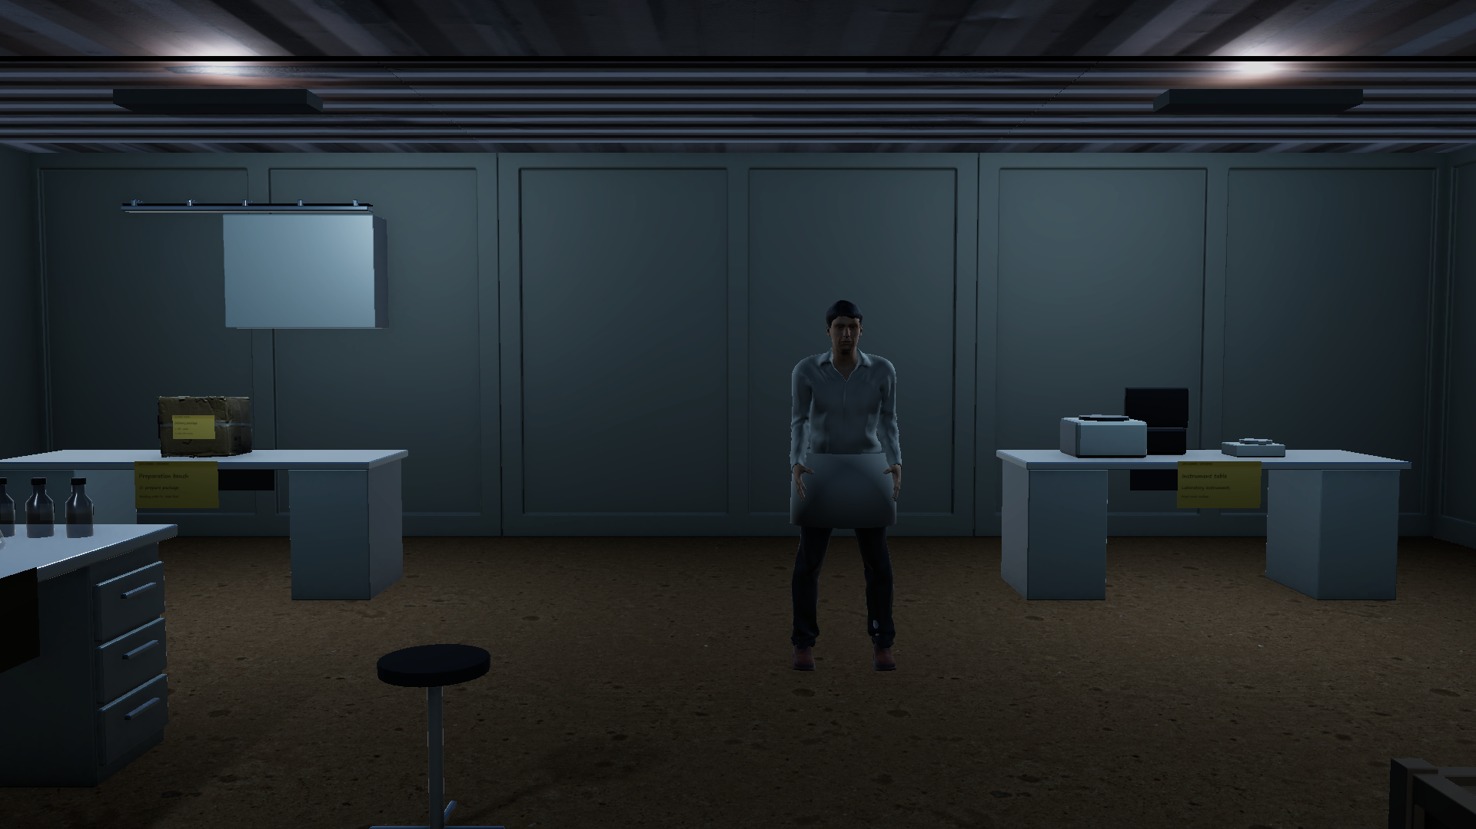
Laboratory work areas in the final authored scene.

Location: road and exterior

Terrain
A five metre asphalt strip runs the full 27 metre north–south extent of the site. Yellow worn markings distinguish the roadway, and gravel shoulders connect it to sand. A short concrete access path links the laboratory entrance to the road. The environment remains a walking level: there are no cars, traffic simulation or driving controls.

Infrastructure
Street lamps, a utility pole, electrical service box, air-conditioning unit, drums and fencing establish the site as a small serviced industrial property. The objects are placed around the route instead of across it. A warehouse facade gives the customer destination a plausible context without introducing another explorable building.

Connections
From the laboratory entrance at approximately X −7, Z 5, the player walks south to the access path at Z 2.7, crosses the road near X 1 and proceeds north on its east side. The bedroom is reached from the southwest. The customer apron is reached farther north, with the counter directly ahead.

Boundaries and feedback
Concrete side walls and north/south fences explain the limits visibly. Player bounds provide a second safeguard if the character reaches the edge. Sand, concrete and asphalt use different footstep sounds. This reinforces surface changes without changing movement speed or introducing friction puzzles.

Lighting
A directional sun changes intensity, colour and angle on a 120 second cycle. This changes atmosphere without failing the objective or spawning hazards. The flashlight remains available outdoors and inside. Sleeping returns the ambient cycle to morning.
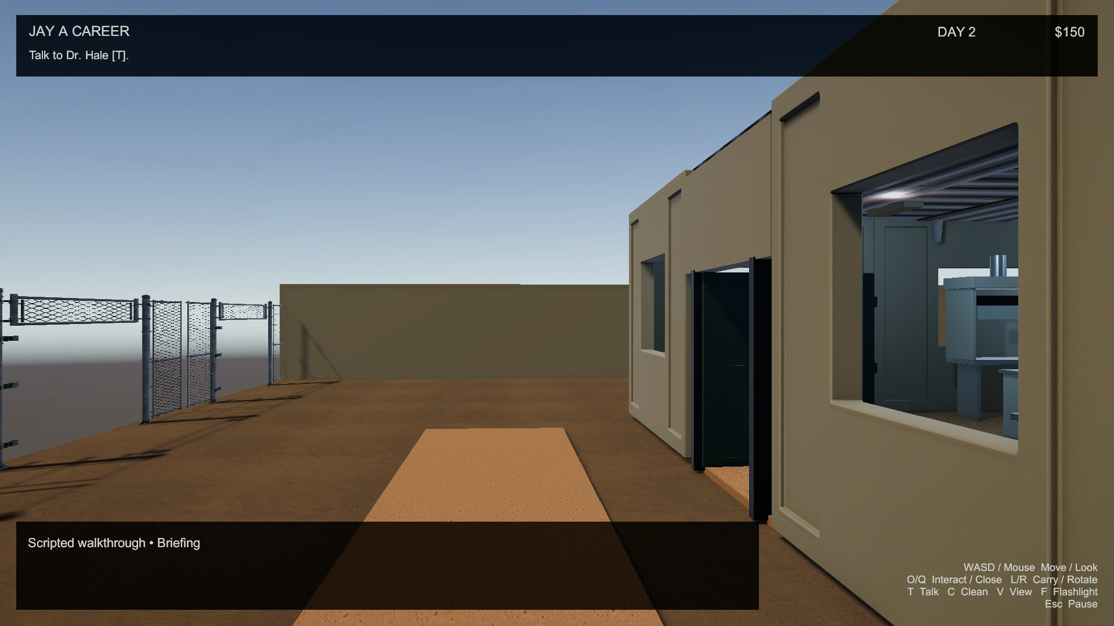
Exterior route, laboratory entrance and industrial boundaries.

Location: customer area

Space and purpose
The customer stands behind a work-height counter on a 12 × 4 metre concrete apron. A warehouse facade, shutter seams, pallet, crate and safety sign make this a service and collection area. The counter is the physical handoff point, separating arrival with a carried package from a ready negotiation.

Approach
The player approaches from the south at about X 9, Z 12.5. The counter sits near Z 14 and the customer near Z 15.4. The front approach leaves enough space to target the counter, place the package, then target the customer. The conversation uses a close-up camera rather than a persistent floating label.

Usability
Only the correct daily package enables negotiation. Dropping while aiming at the counter docks it at the authored handoff slot. The customer will not begin an offer while the package is absent or still being carried. Ordinary crates and drums cannot substitute for the package.

Decision and consequence
The customer offers $50. A accepts, C proposes $75 with a disclosed 50% acceptance chance, and R rejects. A choice resolves the negotiation once. A sale removes the package and increments cash once. Refusal or rejection pays nothing and leaves the same package available for return to the lab.

Day variation
The same humanoid customer alternates between two clothing materials on subsequent days. This is a visual variant, not a new customer AI, a different negotiation model or a new economy. The offer rules stay consistent so the player can understand the daily loop.
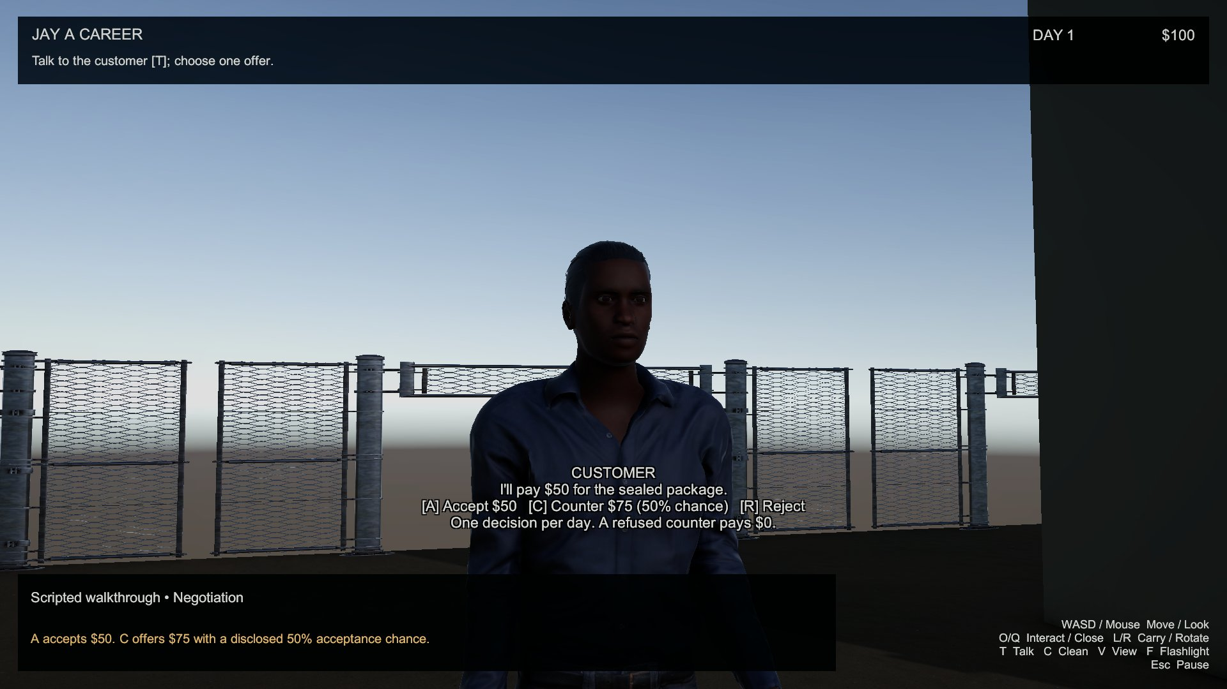
Customer and counter: the package must be present before the offer starts.

Location: bedroom

Role
The bedroom is a separate 7 × 6 metre enclosed room east of the road. Its bed is the final station in the daily sequence. A desk, lamp and chair make the space read as a place to rest, while warmer lighting distinguishes it from the working laboratory.

Route and scale
The entrance is on the southwest side. The player approaches at X 7.7, Z 4.4 and passes through the opening at Z 5.5. The desk is near the back wall at X 9.4, Z 10.6. The bed occupies the east side near X 12.7, Z 9.4. The centre of the room remains the walking approach to the bed.

Bed interaction
O at the bed attempts sleep. Sleep is available only after settlement, any required return and cleaning. An early attempt displays the current objective instead of silently advancing the day. Successful sleep increments the day, hides the package, resets preparation and negotiation, resets daylight to morning and retains accumulated cash.

Furniture interaction
O on the bedroom chair enters a bounded arrangement mode. WASD moves the chair, Q/R rotates it, Enter confirms a clear placement and Esc cancels to the starting transform. Movement stays inside the bedroom arrangement region. Confirmation refuses overlap with other colliders, preserving a usable space.

Scope
The bed does not heal health, consume food, save to disk or advance an external calendar. The room provides task closure and a repeatable session reset. Quitting the game starts a fresh session next time; the document does not claim persistent progression.
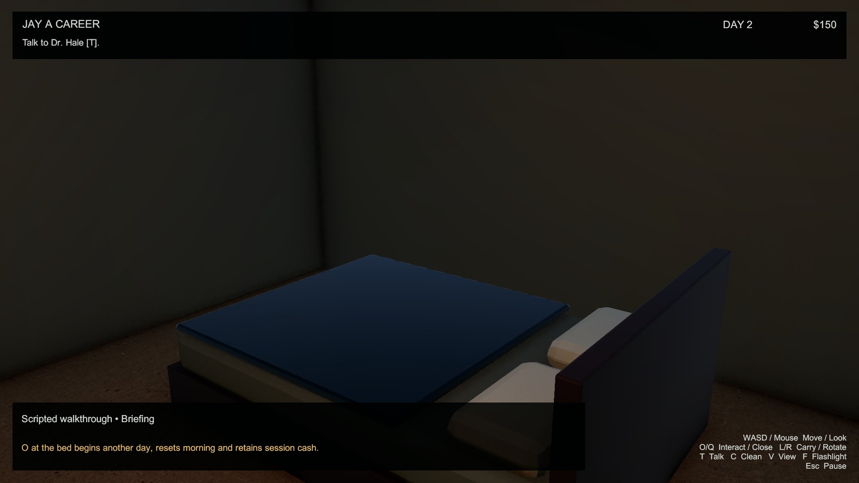
Bedroom route and final daily interaction.

Scale and boundaries
Element | Implemented scale / rule
World | 44 × 27 m; one Unity unit equals one metre
Laboratory | 12 × 12 m; approximately 3.2 m wall height
Bedroom | 7 × 6 m; approximately 3 m wall height
Road | 5 m wide, with gravel shoulders
Door | Approximately 2 m wide panel and 2.1 m high opening
Work surfaces | Approximately 0.9 m above the room floor
Player collider | 1.75 m capsule height, 0.28 m radius, 0.25 m step offset
Interaction range | 3 m camera targeting range
Walking speed | 5 m/s maximum; normalized diagonal input
Playable bounds | X −22…22; Z −3…24; fall recovery below Y −3

Physical boundaries
Walls, roof pieces, cabinets and benches use colliders. The entrance panel rotates around its hinge and continues to collide when open. Closing is refused when its closed volume overlaps the player or a carryable object. Boundary walls and fences give the site an understandable edge.

Walking clearances
The scene is arranged around an open laboratory aisle, a broad road crossing, a front counter approach and the bedroom centre. Decorative objects should stay outside these routes. Measurements are design dimensions from the authored transforms; a route check is still necessary because bounding colliders can occupy more space than a detailed mesh suggests.

Recovery boundaries
Player clamping and fall recovery prevent leaving the playable site. The delivery package separately recovers at the preparation bench when it falls or leaves the bounds. Recovery preserves its daily identity, so the safety system cannot become a source of duplicate deliveries.

Time and world state

Ambient time
The environmental cycle lasts 120 seconds. Sun colour shifts between warm daylight and cool low light; intensity and angle change continuously. The cycle is atmospheric, not a deadline. Walking slowly, rearranging the chair or inspecting the room does not fail the day.

Task time
Task progression is an explicit ordered state sequence. Briefing unlocks preparation. Preparation produces one package. Docking at the counter permits negotiation. A successful sale moves to cleaning; an unsuccessful deal requires return first. Cleaning enables sleep. Sleep begins the next day. World lighting continues while tasks are active.

Pause time
Esc opens the pause panel and freezes scaled time. Resume restores time and mouse capture. The same key first cancels chair placement when arrangement mode is active. Pausing during dialogue does not settle an offer or advance the day.

Session persistence
Day and cash persist only within the running game. Starting a fresh game resets Day 1 and $100. Sleep retains money while resetting the package and briefing state. There is no disk save, autosave, campaign clock, resource expiry or real-time synchronization.

Visual state
Workspace clutter is hidden before preparation, visible while work remains unresolved, and removed by successful cleaning. The package is hidden before preparation and after a sale or sleep. An unsold package remains available until it is returned. The customer material alternates by day, providing small visible variation.

Why this structure
The ambient cycle makes the compact world feel active while explicit task states make progress dependable. The player can recognize both the passing atmosphere and the next action without being punished for learning the controls. Clear denial messages explain which dependency remains.

Objects 1–6
  - Appearance • purpose • usability • gameplay consequence

01 Preparation bench
Bevelled worktop, metal legs, drawers and handles at work height. O creates the daily sealed package after briefing. One package and visible clutter appear; repeat preparation cannot duplicate it.

02 Bedroom desk
Finished desk with a top, drawer and supporting frame. Static bedroom furniture supporting the lamp. It defines the personal space and keeps the bed approach readable. It does not open a computer interface or advance the daily loop.

03 Cleaning sink
Cabinet bench with basin, tap and drain detail. C performs the cleanup action after settlement and required return. It removes stains and used glassware and enables sleep; early cleaning is refused.

04 Wall cabinet
Raised storage cabinet with doors and handles. Static storage scenery above preparation. It explains supplies and creates vertical detail; cabinet doors are not separately operated, and their contents are not inventory.

05 Steel shelves
Open industrial frame with multiple storage levels and worn surfaces. It holds cartons and frames return storage. The shelves establish storage context; their collider blocks walking through the frame. Shelf levels are not separate object types.

06 Return tray
Blue receiving container with side handles, supported in front of storage. L while carrying the unsold package and aiming here docks the return. Only an unsuccessful resolved deal can use it; successful return enables cleaning.
Catalogue rule: repeated copies, colour variants and open/closed states are grouped. The scene also contains the customer counter, instrument bench, bedroom chair, utility pole, signs and three humans. Reused bench and stool models are not needed to inflate this 36-type catalogue.

Objects 7–12
  - Appearance • purpose • usability • gameplay consequence

07 Centrifuge housing
Compact rounded instrument with lid and control detail. Static equipment on the northeast bench. It signals a professional laboratory; no real centrifugation process is simulated, and it does not modify or generate the package.

08 Precision balance
Small instrument with a weighing platform and display housing. Static bench equipment. It adds a distinct measurement prop and scale reference; it does not weigh objects, consume reagents or change the delivery item.

09 Lab terminal
Angled screen and instrument enclosure on the bench. Static visual equipment with a subtle screen material. It improves workstation readability; no computer interface, crafting menu or inventory opens when it is targeted.

10 Fume hood
Tall ventilated enclosure with work surface and front opening. Static west-side laboratory station. It makes ventilation believable and establishes a specialist work area. Its collider contributes to navigation; no air-flow or chemistry system is operated.

11 Test-tube rack
Narrow tubes supported by a structured rack. Static glassware display on the west worktop. It provides a recognizable laboratory object; tubes are not consumables and their repeated instances count as one catalogue type.

12 Graduated beaker
Hollow cylindrical glass vessel with rim and base. Clean glassware is scenery; a separate used instance appears with preparation clutter. The used instance disappears on cleaning. Glassware itself does not produce the package.
Catalogue rule: repeated copies, colour variants and open/closed states are grouped. The scene also contains the customer counter, instrument bench, bedroom chair, utility pole, signs and three humans. Reused bench and stool models are not needed to inflate this 36-type catalogue.

Objects 13–18
  - Appearance • purpose • usability • gameplay consequence

13 Conical flask
Hollow tapered vessel with a narrow neck and glass material. Static glassware on the west bench. Its distinct silhouette supports material and scale recognition; there is no mixing action or operational chemical recipe.

14 Reagent bottle
Sealed bottle with cap and contrasting material. Static supply prop repeated as a group. Repetition suggests stored inventory without adding five distinct object types. Bottles cannot be consumed, sold or substituted for the delivery package.

15 Lab stool
Round seat, legs and foot support at bench height. Static laboratory seating. It supports the working scale and occupies a small collider volume. Sitting is not implemented; the bedroom arrangement chair is a separate interaction using this model.

16 Covered waste bin
Lidded container with a contrasting cap. Static near cleaning. It explains cleanup infrastructure and provides a recognizable disposal prop. It is not a separate disposal, scoring or inventory station; C belongs to the cleaning sink.

17 Lab door
Painted industrial panel beneath a framed opening. O opens; Q attempts to close around a saved hinge pivot. It controls passage and retains collision. Closing refuses occupied space rather than trapping Jay or a carried prop.

18 Window wall module
Framed industrial wall section with an opening. Static laboratory enclosure. It admits views and light while retaining wall collision. Windows do not open. Repeated window modules remain one object type regardless of their position.
Catalogue rule: repeated copies, colour variants and open/closed states are grouped. The scene also contains the customer counter, instrument bench, bedroom chair, utility pole, signs and three humans. Reused bench and stool models are not needed to inflate this 36-type catalogue.

Objects 19–24
  - Appearance • purpose • usability • gameplay consequence

19 Solid wall module
Painted modular panel with structural framing. Static laboratory enclosure and navigation boundary. It prevents walking and targeting through the shell. Different instances and rotations count as one type; they do not imply destructible walls.

20 Roof module
Flat metal roof piece with manufactured edges. Static overhead enclosure with continuous backing. It completes both camera views and keeps the lab spatially enclosed. Roof pieces are not climbable, removable or part of a construction system.

21 Wall vent
Rectangular industrial ventilation grille high on the wall. Static service detail. It supports ventilation storytelling without an air-flow simulation. Its purpose is visual context, so it has no separate interaction prompt or progression consequence.

22 Exhaust pipe
Narrow industrial pipe sections near the ceiling. Static utility detail. It connects the room visually to services; repeated pipe sections are one catalogue type. Pipes are not carryable and do not transport a simulated resource.

23 Cable tray
Original overhead channel with restrained cable detail. Static near the back wall. It creates plausible electrical routing without a wiring puzzle. Its placement keeps cables outside the walking route and avoids turning decoration into an obstruction.

24 Light switch
Small high-contrast wall plate near the entrance. O toggles four laboratory fixtures as one group. It changes local visibility independently of ambient time and flashlight. The switch does not reset task state or consume power.
Catalogue rule: repeated copies, colour variants and open/closed states are grouped. The scene also contains the customer counter, instrument bench, bedroom chair, utility pole, signs and three humans. Reused bench and stool models are not needed to inflate this 36-type catalogue.

Objects 25–30
  - Appearance • purpose • usability • gameplay consequence

25 Ceiling fixture
Long rectangular light housing above work areas. Saved light sources respond to the wall switch. They provide cool room illumination. Fixture copies do not count as separate types; only one local lab light casts a shadow for cost control.

26 Sealed delivery carton
Textured cardboard package with visible tamper strip. L picks up/places; R rotates; valid counter/return docks accept it. It represents the single daily transaction. Identity prevents substitution, duplicated preparation and additional payment after settlement.

27 Supply crate
Small wooden industrial crate with manufactured edges. L carries it, R rotates it and L places it on a clear surface. It demonstrates ordinary prop handling without unlocking negotiation or paying cash. It cannot replace the daily package.

28 Industrial drum
Worn blue plastic barrel with rim and lid detail. An empty laboratory variant is carryable; exterior copies are scenery. It adds storage realism. Ordinary drums cannot become packages, and colour or placement variants are not distinct types.

29 Wooden pallet
Low timber platform beneath warehouse cargo. Static customer-area service prop. It supports cargo visually and distinguishes the receiving apron from the lab. It is not a vehicle, movable platform or separate storage inventory.

30 Bedroom lamp
Small shaded lamp on a finished desk. Static bedroom decoration that makes the room read as a personal space. A separate saved warm room light provides illumination; this prop has no individual switch and does not duplicate the laboratory lighting mechanic.
Catalogue rule: repeated copies, colour variants and open/closed states are grouped. The scene also contains the customer counter, instrument bench, bedroom chair, utility pole, signs and three humans. Reused bench and stool models are not needed to inflate this 36-type catalogue.

Objects 31–36
  - Appearance • purpose • usability • gameplay consequence

31 Warehouse facade
Industrial frontage with roller shutter and seams. Static background building at the customer area. It explains the destination and limits the view. The shutter does not open and its interior is outside playable scope.

32 Chain-link fence
Industrial mesh boundary panels at site edges. Static visible boundary. It communicates the map limit before Jay reaches clamped bounds. Panels are not climbable or destructible; repeated panels count as one type.

33 Street lamp
Tall roadside pole with lamp head. Static exterior infrastructure. It establishes road scale and a serviced site. No separate street-light switch is implemented. Lamp instances do not add new lighting behaviours to the three required demonstrations.

34 Electrical service box
Metal utility enclosure mounted outside the lab. Static infrastructure. It suggests supplied power and adds believable exterior detail. There is no repair mechanic, fuse inventory or power outage objective associated with this prop.

35 Air-conditioning unit
Vented exterior machine with fan housing. Static on the lab exterior. It supports the industrial setting; its equipment is not player-operated. Machinery ambience provides atmosphere without claiming a temperature or ventilation gameplay simulation.

36 Bedroom bed
Finished mattress, frame, pillow and bedding. O attempts sleep once work is complete. It advances the day and resets morning while keeping session cash. Early sleep is denied, and it does not save progress to disk.
Catalogue rule: repeated copies, colour variants and open/closed states are grouped. The scene also contains the customer counter, instrument bench, bedroom chair, utility pole, signs and three humans. Reused bench and stool models are not needed to inflate this 36-type catalogue.

Movement and controls
Context | Input | Behaviour
Explore | WASD / mouse | Normalized movement / clamped mouse look
Door | O / Q | Open / close if unoccupied
Station | O | Prepare, sleep or switch lab lights
Carryable prop | L / R | Pick up or place / rotate 45°
Conversation | T | Begin talk; continue Hale briefing
Customer offer | A / C / R | Accept $50 / counter $75 at 50% / reject
Cleaning sink | C | Clean when required work is resolved
View | V | First person / third-person follow
Flashlight | F | Toggle camera-mounted spotlight
Pause | Esc | Pause; Resume and Quit buttons
Arrange chair | O, WASD, Q/R | Enter mode; move and rotate
Arrange chair | Enter / Esc | Confirm clear placement / cancel

Terrain navigation
Jay walks with a CharacterController. Gravity holds the capsule on floors and the step offset permits small height changes. There is no jump, crouch, sprint, swimming, climbing or vehicle traversal. The access path, road crossing and open room aisles provide the intended route.

Input precedence
Pause is handled first, except Esc cancels active chair arrangement. During dialogue, A/C/R belong to the customer offer before movement, cleaning or carried rotation. Hale uses T only. A carried object owns L/R before world targeting. These priorities prevent one key press from triggering two unrelated actions.

Interactions and targeting
A short camera sphere cast selects the first collider within three metres. An interactable component on that root supplies the prompt. Walls and ordinary scenery block the cast. The player must aim at the station rather than interact with an object by its name or distance alone.

Mechanics 1–4
  - Input • rules • feedback • relevant edge cases

M01 Locomotion and collision
WASD moves at up to 5 m/s; diagonal input is normalized. Gravity and a 1.75 m CharacterController keep Jay on surfaces. Movement is blocked by room and prop colliders. Falling below the recovery height returns Jay to the safe path. There is no jump or sprint.

M02 Mouse look and aiming
Mouse delta rotates Jay horizontally and the look pivot vertically, with pitch clamped to −80…80 degrees. The aiming direction drives targeting and placement. Mouse capture is restored by Resume. Looking does not move the character or settle dialogue. First and third person share this aim input.

M03 Contextual interaction selection
A camera sphere cast reaches three metres and selects the first collider. The root component defines the meaningful key and supplies a prompt. Obstructions stop the cast. Empty scenery does not fall through to a hidden named object behind a wall. Unavailable progress actions explain their requirement.

M04 Hinged door operation
O rotates the entrance panel around its saved hinge; Q requests closure. Opening/closing are one mechanic. The panel retains collision while open. Closing checks the closed volume against Jay and liftable props, refusing occupied space and giving feedback. Repeated open/close requests do not spawn extra panels.
Implementation reference: JayDailyLoop contains session rules; JayGameManager connects them to the saved scene. JayPlayerController resolves input; dedicated components handle the hinge, docks, stations, lighting and cameras.

Mechanics 5–8
  - Input • rules • feedback • relevant edge cases

M05 Briefing gate
T on Dr. Hale begins his briefing and T continues/closes it. The first briefing changes Briefing to Preparation. A/C/R offer controls are absent. Talking to Hale later displays instructions without creating another package or bypassing the current task. Dialogue returns to the previously selected normal camera.

M06 Daily package preparation
O on the preparation bench creates one available sealed package after briefing. Workspace stains and used glassware activate. Repeating preparation preserves identity and can recover the existing package when appropriate. It cannot create another sale item. The objective directs Jay to delivery, and early sleep remains unavailable.

M07 Single-object carrying
L on a liftable root attaches it to the carry point. Only one object can be held; carried colliders are disabled. The daily package updates ownership. Ordinary crates, drums and cartons can be carried but cannot satisfy a daily handoff. Dialogue is unavailable while holding an object.

M08 Carried orientation
R rotates the held object in 45 degree increments. Rotation is visible in either normal view and remains with the object when placed. During customer dialogue R instead rejects the offer, because dialogue has precedence. Rotation alone does not change package ownership, cash or the daily stage.
Implementation reference: JayDailyLoop contains session rules; JayGameManager connects them to the saved scene. JayPlayerController resolves input; dedicated components handle the hinge, docks, stations, lighting and cameras.

Mechanics 9–12
  - Input • rules • feedback • relevant edge cases

M09 Clear-surface placement
L while carrying tests a targeted upward-facing surface or nearby floor candidate. Collider dimensions offset the object above the surface. An overlap check refuses blocked space. Failure keeps the object held. Successful ordinary placement restores collision; a package drop records World ownership so recovery and negotiation remain consistent.

M10 Counter handoff
Aim at the customer counter and press L with the daily package to snap it to the authored handoff slot. Delivery changes to Negotiation. A different prop cannot unlock the offer. Picking the package back up before settlement returns to Delivery. The counter supplies a clear contextual dock prompt.

M11 One-shot negotiation
T on the customer requires the correct package at the counter. A accepts $50, C counters $75 with a disclosed 50% chance, R rejects. These are alternatives of one mechanic. A decision ends the conversation and resolves the offer once. A refused counter cannot be retried for another roll.

M12 Cash settlement
A sale adds payment once and transfers the package to Sold; it disappears. Acceptance pays $50, successful counter pays $75, rejection/refusal pays $0. Repeated resolve calls cannot pay again. Cash starts at $100 and persists across sleep in the same session. It does not purchase upgrades in this revision.
Implementation reference: JayDailyLoop contains session rules; JayGameManager connects them to the saved scene. JayPlayerController resolves input; dedicated components handle the hinge, docks, stations, lighting and cameras.

Mechanics 13–16
  - Input • rules • feedback • relevant edge cases

M13 Unsold return
After refusal or rejection, L retrieves the same package and L at the return tray docks it in the lab. Cleaning remains unavailable until return. The tray is not an alternative sale or a way to skip negotiation. Returned packages cannot be picked up for another offer that day.

M14 Visible cleanup
C at the sink succeeds only after settlement and required return. Stains and used glassware disappear and Dirty becomes false. The objective changes to sleep. C early explains outstanding work without clearing clutter. C during customer dialogue belongs to the counteroffer, so it cannot clean remotely.

M15 Sleep and next day
O at the bedroom bed succeeds only in Sleep. Day increases, briefing and package state reset, and daylight returns to morning. Cash remains accumulated and customer clothing alternates. Early sleep is denied. New preparation requires the next briefing. Quitting still resets the entire session next launch.

M16 Package recovery
The package is monitored for falls or leaving the site. Recovery returns the same item to preparation; the bench can also recover it during delivery/return. Its identifier stays unchanged. Sold, returned or carried packages cannot be recovered into duplicates. Recovery during negotiation returns the stage to Delivery.
Implementation reference: JayDailyLoop contains session rules; JayGameManager connects them to the saved scene. JayPlayerController resolves input; dedicated components handle the hinge, docks, stations, lighting and cameras.

Mechanics 17–20
  - Input • rules • feedback • relevant edge cases

M17 Bedroom chair arrangement
O starts chair editing from its current transform. WASD moves within the bedroom region; Q/R rotates. Enter confirms only a clear collider volume. Esc restores the starting transform. Jay stays still during editing. Arrangement never advances the daily task, and invalid confirmation leaves the chair editable.

M18 First/third-person selection
V switches saved Cinemachine priorities between first person and damped third-person follow. Jay’s body is hidden in first person and visible in third person. Follow uses obstacle avoidance and ignores the player tag. The choice does not change interaction range, walking speed or package ownership.

M19 Dialogue focus and return
A valid conversation promotes the saved dialogue camera, aimed at the speaker’s head, with a 0.45 second blend. Ending briefing/offer restores the normal view. It differs from manual V selection because it is task-driven, targets an NPC and returns automatically. Invalid customer talk never starts the focus.

M20 Ambient lighting cycle
The sun changes intensity, colour and angle over 120 seconds. Time never fails the task. Sleep resets the cycle to morning; pause freezes it through scaled time. The player can compare daylight and low light without losing progress. This does not create weather, traffic or new NPC schedules.
Implementation reference: JayDailyLoop contains session rules; JayGameManager connects them to the saved scene. JayPlayerController resolves input; dedicated components handle the hinge, docks, stations, lighting and cameras.

Mechanics 21–23
  - Input • rules • feedback • relevant edge cases

M21 Flashlight
F toggles a camera-mounted spotlight independently of the laboratory switch. It follows view direction and improves local readability in low light. There is no battery resource, recharge station or damage effect. Turning it off does not advance the task. It remains available during ordinary first or third-person exploration.

M22 Laboratory light group
O at the labeled entrance switch toggles all four saved work lights together. They start off. Clear window openings admit sunlight and shadowed daylight fill; low ambient colours keep deeper areas subdued. Night is dark with both fixtures and flashlight off. The switch does not affect progression. Sleep resets ambient time without changing the switch state.

M23 Pause and resume
Esc toggles the panel, scaled time and cursor capture. Resume restores play; Quit exits. Pause preserves dialogue and task state. Arrangement cancellation takes precedence over pause. Resuming cannot create a payment, reset a day or remove clutter. The two buttons provide visible alternatives to keyboard control.

Supporting feedback
Objectives, contextual prompts, placement sounds, surface-aware footsteps and machinery ambience support these mechanics. They are feedback channels, not extra mechanics counted to meet the requirement. Ordinary movement variants, door states and offer alternatives are likewise grouped.
Implementation reference: JayDailyLoop contains session rules; JayGameManager connects them to the saved scene. JayPlayerController resolves input; dedicated components handle the hinge, docks, stations, lighting and cameras.

Daily loop and state dependencies
State | Available progress | Next state
Briefing | T on Hale, T continue | Preparation
Preparation | O at preparation bench | Delivery
Delivery | Carry and dock package at counter | Negotiation
Negotiation | Accept / counter / reject once | Cleaning on sale; Return otherwise
Return | Carry unsold package to return shelf | Cleaning
Cleaning | C at sink removes clutter | Sleep
Sleep | O at bed | Next day: Briefing

State invariants
Only one delivery identity is created per day. A sale requires that package at the counter. Settlement is final for the day. Unsuccessful deals require physical return before cleaning. Sleep requires cleanup. These invariants eliminate repeated preparation, repeated counter rolls, duplicate payments and skipping directly to another day.

Recoverable mistakes
A package on an ordinary surface remains available. A lost package returns to preparation with the same identity. Picking it off the counter before settlement changes the objective back to delivery. Blocked placement leaves the object carried so the player can choose another surface.

Player feedback
Denied progress actions report the objective or a specific requirement. The HUD shows day, cash and next task. Physical clutter and package visibility agree with the sequence, reducing reliance on a written walkthrough. The next day is always reachable after either a sale or an unsuccessful deal.

Resource management and negotiation
Choice | Probability | Payment | Required next work
Accept | 100% | +$50 | Clean, then sleep
Counter accepted | 50% | +$75 | Clean, then sleep
Counter refused | 50% | $0 | Return, clean, sleep
Reject | Player decision | $0 | Return, clean, sleep

Risk and expected value
Accepting is reliable. A counter has an expected payment of $37.50: 0.5 × $75 + 0.5 × $0. The higher successful payout is balanced by refusal and a return trip. The chance is disclosed in the conversation, so the choice does not depend on hidden information.

Resources
Cash is the session score and does not buy equipment. The package is a daily transaction resource with tracked ownership. Cleanliness is a task condition rather than numeric durability. Time is atmospheric rather than a consumable deadline. There is no health, ammunition, fuel or hunger system.

Weapons applicability
Weapons, combat and vehicle controls are outside this walking and delivery game. The road supports the setting and traversal. Instruments and reagents are scenery rather than weapons or operational chemistry systems. No combat controls are presented to the player.

Fairness and recovery
An unsuccessful negotiation does not end the session. Return, cleaning and sleep always provide a route to the next day. Package recovery prevents a misplaced item from permanently blocking progress while retaining one-package and one-payment rules. Restarting the application begins a fresh Day 1 with $100.

Cinemachine implementation evidence
Behaviour | Implementation | Demonstration
First person | Saved CM First Person follows the look pivot with zero offset and view rotation. | Default exploration; Jay body hidden.
Third-person follow | Saved CM Third Person Follow: damped shoulder, 2.8 m distance, obstacle avoidance. | V on delivery route; Jay visible and animated.
Dialogue focus | Saved CM Interaction Close Up follows speaker head and uses Hard Look At. | T on Hale/customer; 0.45 s blend, then return.

Camera ownership
One output camera has a CinemachineBrain. The controller changes priorities and targets; it does not create additional cameras each time Play starts. All three Cinemachine cameras are saved in the authored scene. Normal view is restored after dialogue.

Obstructions and framing
Third-person follow uses obstacle avoidance. Dialogue offsets place the camera in front of stationary NPCs and target the head. The first-person near plane is 0.08 m and physical collision limits walking through walls. Carried objects sit below the reticle to keep the route readable.
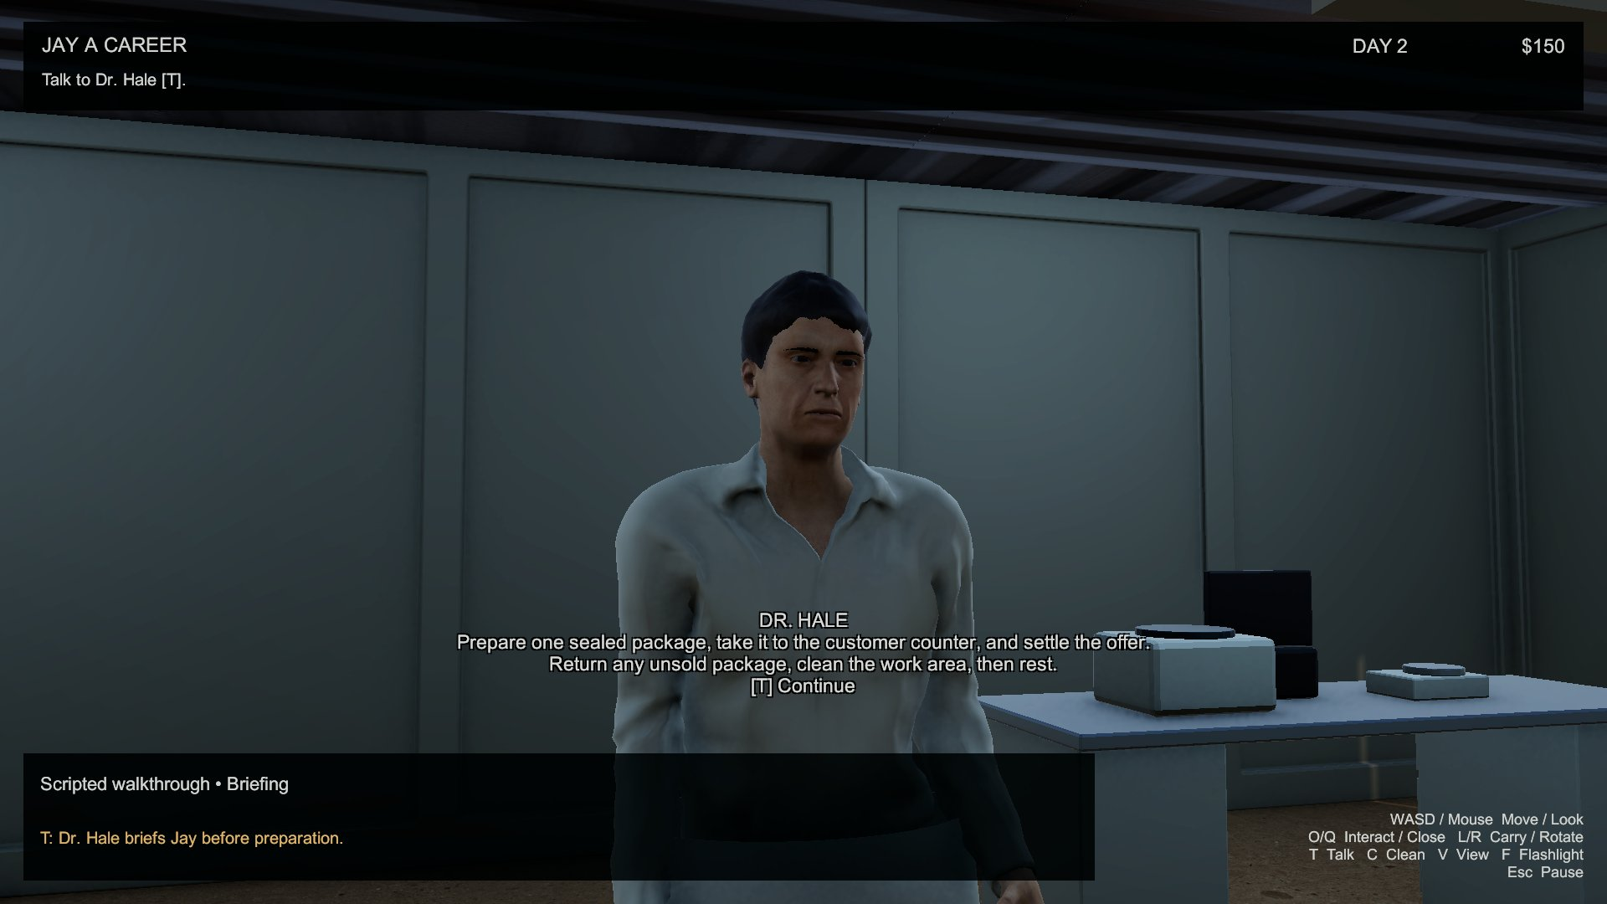
Dialogue focus uses the NPC head target rather than a floating world label.
Evidence: scene-checks.json verifies three Cinemachine cameras. The demonstration shows normal and dialogue transitions on the same route. Future changes to furniture or NPC positions require another obstruction and framing review.

Lighting implementation evidence
Behaviour | Control / timing | Visible consequence
Ambient cycle | Automatic, 120 seconds | Sun intensity, angle and warm/cool colour change.
Flashlight | F | Camera-mounted spotlight toggles independently.
Laboratory group | O at entrance switch | Four cool laboratory work lights toggle together.

Layered readability
The sun gives the exterior a warm desert atmosphere. Cool fixtures separate work from rest and a warm bedroom light marks the destination. The flashlight remains available in low ambient light. The cycle changes atmosphere without locking any interaction.

Materials and post-processing
URP Lit uses separate diffuse and normal maps and packed metallic/smoothness where relevant. Roughness is inverted to smoothness. Nonmetal ground surfaces have restrained normals and disabled specular/environment contributions to avoid a wet appearance. ACES adds modest exposure, contrast and bloom.

Cost controls
Four switchable lab point lights provide coverage; only one casts a local shadow. Five shadowed daylight spotlights approximate sky light through clear window openings and follow the 120-second cycle. Direct sun enters open windows and the door. Low Trilight colours and reduced night reflections prevent uniform room brightness. Texture imports and shadow maps are capped for this compact scene.

Reset and independence
Sleep resets ambient time to morning without toggling flashlight or the lab switch. Pause freezes the cycle. Integration checks independently toggle the flashlight and all four work lights. The demonstration compares switched lab illumination and the flashlight along the same route.
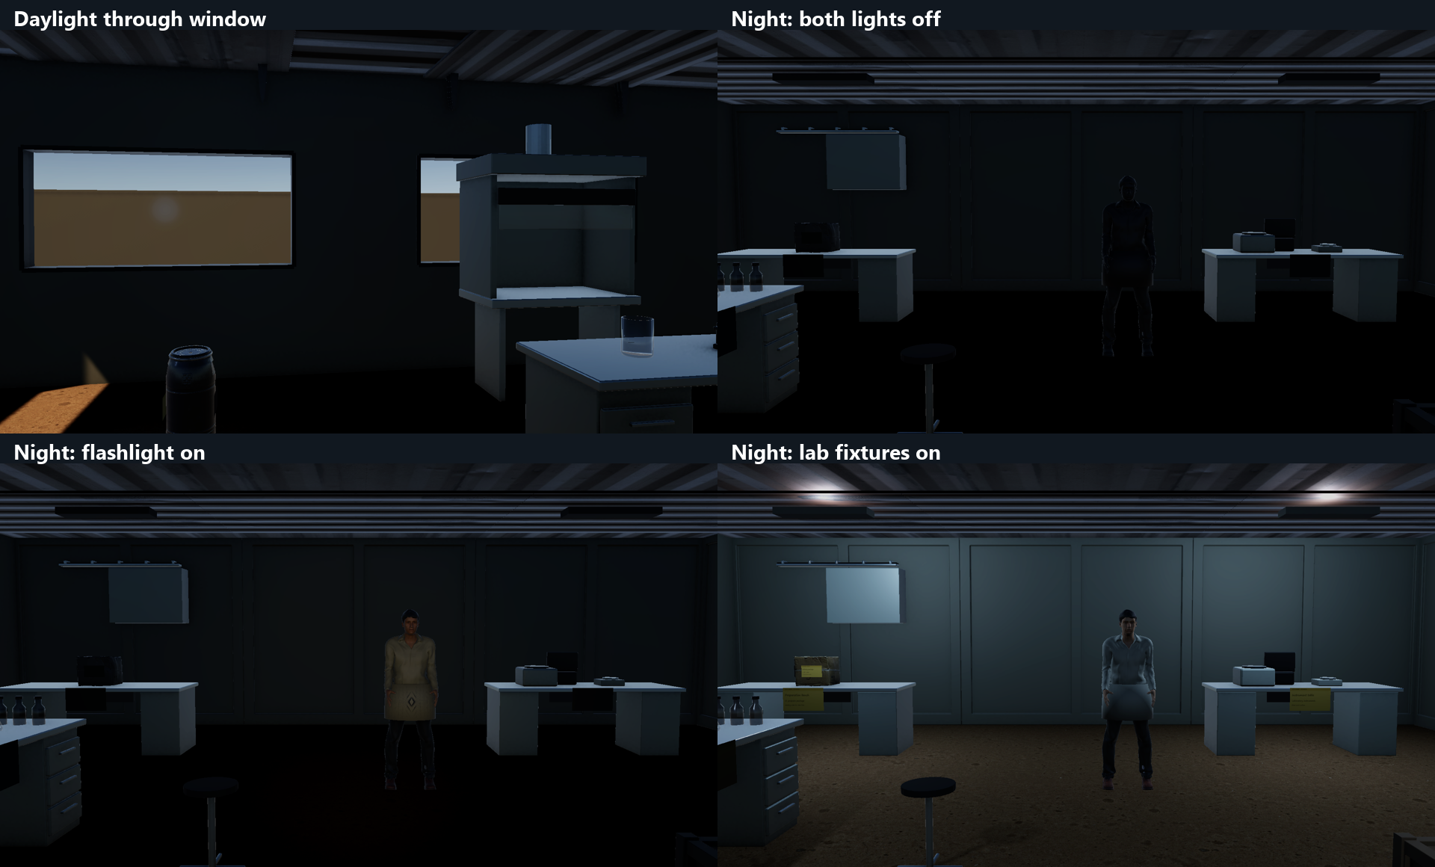
Flashlight and lab switch are independent of the ambient cycle.

Five action demonstrations
Action | Input and precondition | Cause and effect
1. Preparation | O at bench after briefing | One package activates; clutter appears.
2. Carry / rotate / place | L on package, R in hand, L at counter | Ownership/location changes; package docks.
3. Negotiate | T with package docked; A/C/R once | Sale pays once; refusal/rejection requires return.
4. Clean | C at sink after resolved delivery/return | Clutter disappears; bed becomes available.
5. Sleep | O at bed after cleaning | Day advances, morning resets, cash stays.

Demonstration order
Show objective, targeted station, prompt and visible result. The first day demonstrates acceptance and payment. The second demonstrates rejection, return and another reset. Counter success/refusal are covered separately by deterministic rule and scene checks. The video is a scripted route captured from the authored Unity scene; Windows build validation is recorded separately.

Supporting interactions
The hinge, ordinary prop carrying, chair arrangement, view toggle, flashlight, lab switch and pause panel provide additional evidence. They do not replace these five actions. The normal executable remains manually playable; evidence automation runs only when explicitly requested with its command-line flag.

Input distinction
A/C/R belong to the customer conversation before movement, cleaning or rotation. Hale uses T. C cleans only during ordinary exploration at the sink, while C in an offer counters. R rotates a held object outside dialogue and rejects an active customer offer. The same keys therefore have explicit, visible contexts.

Validation and implementation limits

Rule tests
The focused JayDailyLoop checks passed 72 assertions. They exercise all four negotiation outcomes, duplicate settlement prevention, invalid early actions, package identity and two consecutive day resets. Tools/rules_checks.cs and Evidence/daily-rules-tests.json retain the reproducible test and result.

Scene integration
The prior saved scene passed 61 integration checks. The labeled full-build Windows player passed 40 input/physics assertions: Resume mouse capture, dialogue keys, single payment, package handoff/return/recovery, prop placement, door obstruction, chair arrangement, cameras and lights. See windows-labeled-input-checks.json. The user passed physical movement, pause, camera, door and flashlight checks on the preceding full build. Targeted label, lift/place and lighting feedback is pending.

Route and performance
The scripted demonstration uses CharacterController walking between the four locations. Windows benchmark mode uses the same route without image capture. Reports record completion, day/cash, resolution, hardware and frame statistics. Benchmark mode records without screenshot encoding; demonstration capture adds overhead and is not the performance acceptance result.
Visible Windows route: completed=True; Day 3, cash $150; 1920 × 1080; average 59.8 FPS, 1% low 58.6 FPS. This passes the 30 FPS minimum and approaches the 60 FPS target on AMD Ryzen 7 4800H with Radeon Graphics ; NVIDIA GeForce GTX 1650.
The labeled full Unity BuildPipeline.BuildPlayer build succeeded on 15 October 2026: 0 errors, 1 warning(s), 35.0 seconds. Scene data and scripts were rebuilt together using a project-local Bee response-file launcher and Unity's original generator. The final build CLI exited successfully with code 0; the complete output copy is documented in labeled-copy-provenance.json. The updated silent video is a scripted Windows player recording, separate from uncaptured benchmark timing.

Practical limits
Characters use original simple idle, walk, talk and handoff clips rather than motion capture. Hale’s white long-sleeve jacket is an adapted fitted garment. Instruments are visual housings. There is no save system, advanced NPC navigation, dynamic traffic, combat or real chemistry simulation. Future additions must be labelled separately.

Asset credits and dependencies
New downloaded art/audio assets are CC0. Original laboratory models, simple animations and synthesized ambience were authored for this revision. REALISM_ASSET_CREDITS.md and asset-register.json record source, author, license, downloaded snapshot/version and modifications. Original license files and metadata are retained.
Group | Source / author | Use and adaptation
Architecture | ModKit v1.2 / Jaron K. Bragg | Existing FBX modules; placement, pivots and materials.
Surfaces | Poly Haven / per-asset metadata | Asphalt, concrete, sand, painted metal; complete 1K maps.
Industrial props | Poly Haven artists | Shelves, barrel, box, lamp, pole, fence, utility box, AC; FBX and scale adaptation.
Humans | MakeHuman Community CC0 system assets | MPFB bodies, skin, hair, clothing, shoes; original clips and Hale garment recolour.
Laboratory / bedroom | Original Blender work | Benches, cabinets, sink, glassware, instruments, bed, desk, lamp, props.
Audio | Kenney; original synthesis | Confirmation and placement; original surface steps, fan and wind.

Authoring versus runtime
Blender 4.5.14 LTS and MPFB 2.0.18 generate FBX and textures. MPFB software is GPL-3.0; selected system assets are CC0. The game does not require Blender/MPFB. Unity 6000.3.24f1, URP 17.3.0 and Cinemachine 3.1.5 are retained. Packages files resolve exact dependencies; Unity Pipeline 0.8.0-exp.1 supports editor automation.
Primary sources: https://polyhaven.com/license ; https://static.makehumancommunity.org/assets/assetpacks/makehuman_system_assets.html ; https://github.com/JaronKBragg7337/asset-pack-ue-threejs-blender-unity ; https://kenney.nl/assets/impact-sounds ; https://kenney.nl/assets/interface-sounds

Reflection and handoff

What changed
The runtime-built prototype was replaced by an authored scene with saved roots and reusable prefabs. The lab has a complete shell, specialist areas and manufactured prop geometry. Infrastructure and a finished bedroom support the route. Three rigged humans replace placeholders. The daily loop has explicit dependencies and recoverable unsuccessful deals.

Why it matters
Saved scene authoring makes furniture, characters and lights editable without replacement at Play. Separating rules from presentation makes payment/progression easier to inspect. Stable component references avoid fragile object-name routing. Surface maps, scale and enclosure improve realism together; importing more objects alone would not make the task sequence coherent.

Trade-offs
The compact site permits detail without a town simulation. Original instruments provide laboratory context while remaining scenery. Simple animation is consistent and free but lacks motion-capture subtlety. The session economy makes repeatable days demonstrable without save compatibility work. The visual target is a polished student project rather than a photorealistic commercial production.

Implemented and future
Implemented: authored four-zone site, package ownership/recovery, one-shot negotiation, return, cleanup, sleep reset, session cash, humans, three cameras, three lighting behaviours, contextual HUD, pause and chair arrangement. Future: saves, broader customer variety, richer acting, more sound variation and baked lighting refinement. Driving, combat and a larger town remain outside scope.

How to review
Open Assets/JayACareer/Scenes/JayACareer_Realism.unity in Unity 6000.3.24f1 or run the Windows executable. Start by talking to Hale. Review map, video and Evidence alongside this document. The archive includes source assets/settings and excludes generated caches. Visual desert scenery extends beyond the fixed walking bounds. Publication and course submission are separate later actions.

